**Detailed dataset information sheet**

|  |  |
| --- | --- |
| **Information Objective** | Roads and Transport Hubs |
| **Data Products** | Transport Hubs and Container Yards |
| **Information Source / Model Product** | Google Maps, Earth and Search Engine |
| **Product Completion Progress** | Initial AA Seaports proximity complete  ABS Industrial Meshblocks in progress |
| **Dataset / Metadata Document** | Australia - Container and Car Storage Yards and Transport Hubs GDB  Container Yards and Transport Hubs Metadata.pdf |
| **Dataset Use** | Surveillance Strategy and Design, Pathway risk analysis |

**Background**

A national point feature spatial dataset layer identifying major freight and logistics operations, and container, car and pallet storage yards has been developed utilising publicly available information on Google Earth, Google Maps and associated search engine.

The initial facilities identified are those in close proximity to an Australian Port of Entry. These ports are listed in detail on the [Department of Home Affairs](https://www.homeaffairs.gov.au/trav/ente/avia/maritime/ports-of-entry) website.

**Initial Dataset Procurement Process**

The dataset has been derived by a number of manual processes:

* An initial search of the Google Earth and Google Maps engines with key words “container storage yard” and “freight forwarding services” was conducted
* Creation of a KML layer within Google Earth once suitable sites were confirmed visually from publicly available satellite and street view imagery
* Creation of a 2 kilometre buffer within ArcMap around the AA ports of entry which is then imported into Google Earth as a layer (Figure 1)
* Visual scan of the environment within and surrounding these buffers and the facilities captured from the search results to identify and capture other container, car and pallet storage yards and rail and vehicle freight hubs (Figures 2-6)
* Export of the final Google Earth KML layer to file
* Conversion of this layer within ArcMap using the KML to Layer (Conversion) tool to create and editable shapefile layer

Figure 1. Google Earth view of “freight forwarding services” search results and AA port of entry 2km buffer (orange circle)

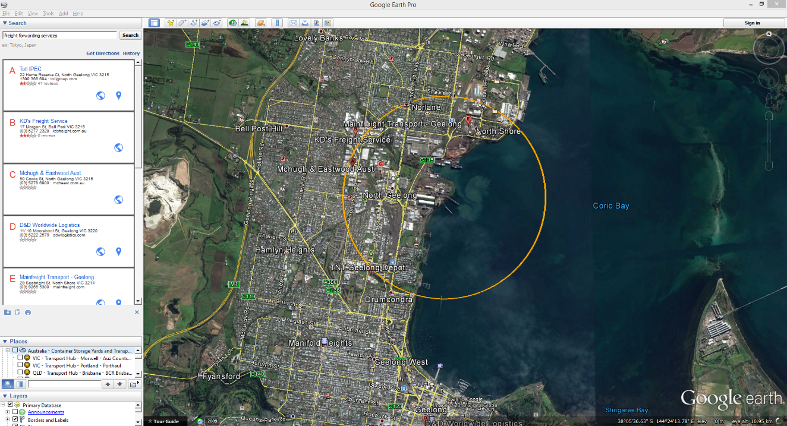

Figure 2. Google Earth view of captured facility locations” and AA port of entry 2km buffer (orange circle)

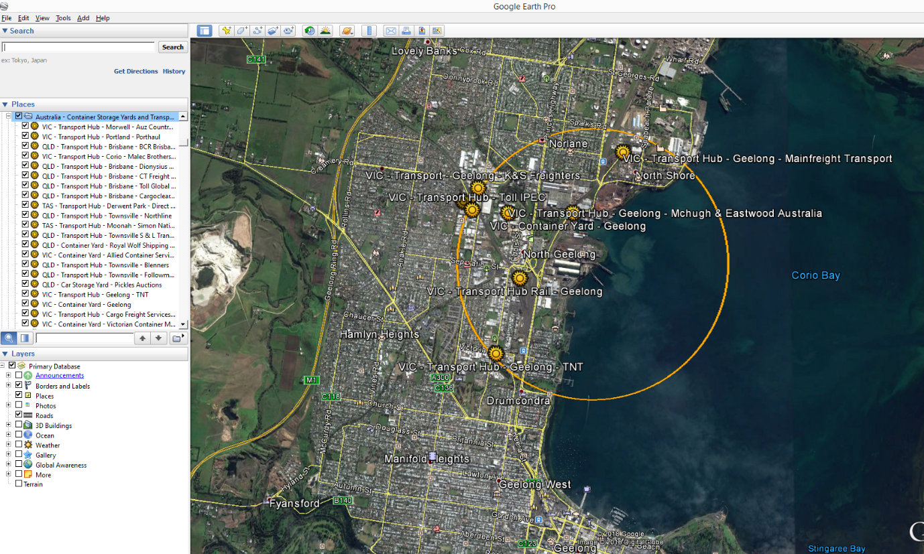

Figure 3. Google Earth close-up view of captured Container Storage Yard facility

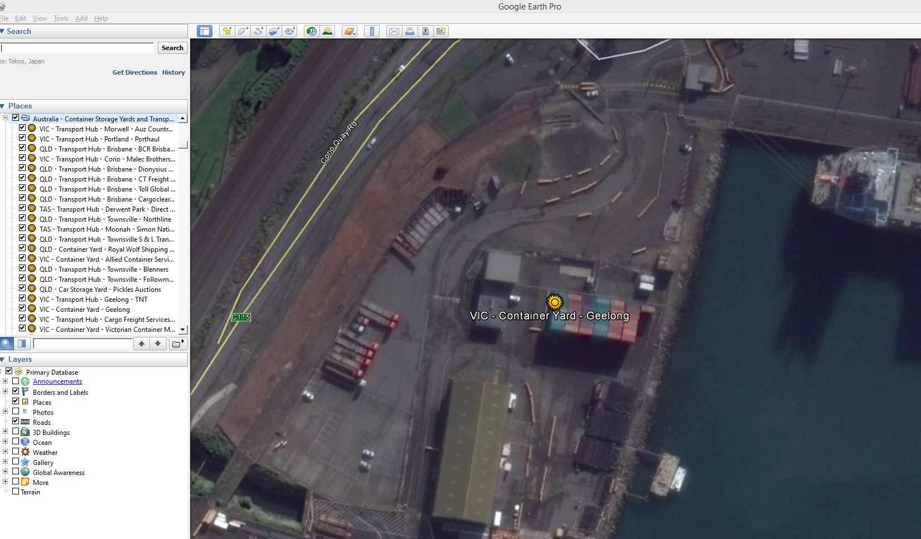

Figure 4. Google Earth close-up view of captured vehicle freight forwarding services facility

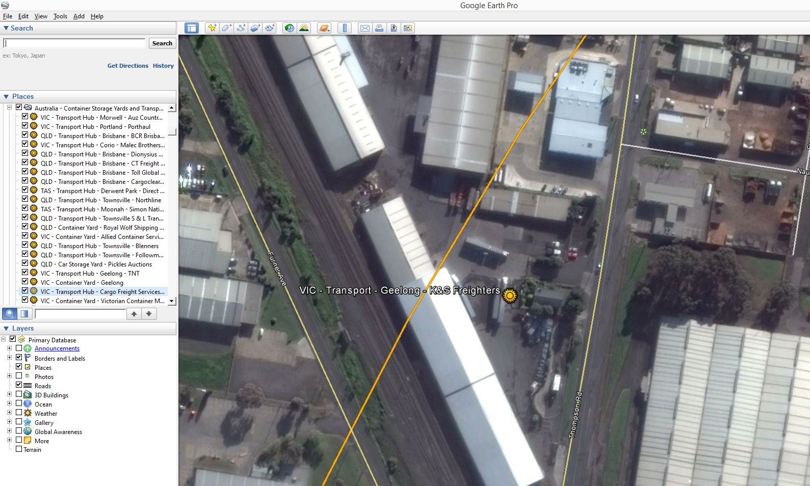

Figure 5. Google Earth close-up view of captured car storage yard facility

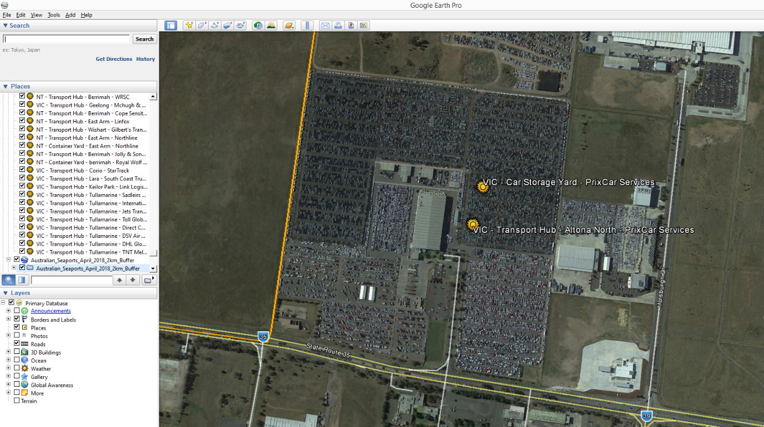

Figure 6. Google Earth close-up view of captured pallet storage yard facility

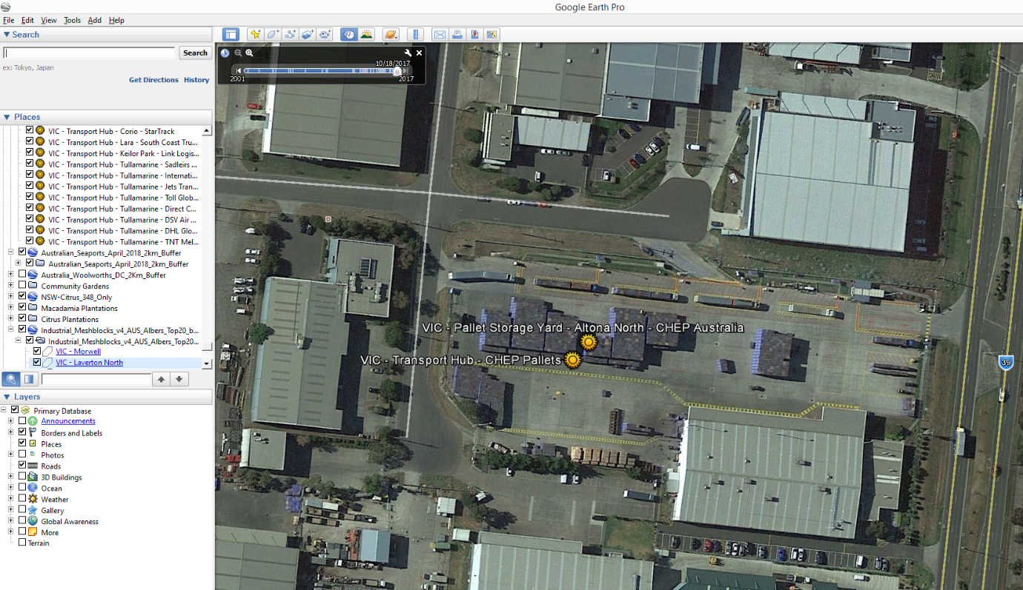

**In progress Dataset Procurement Processes**

In an attempt to fast track this data capture process, it was hypothesised that the state level ABS Meshblock data when filtered for key land use categories such as “Industrial” could serve as a proxy representative dataset.

This dataset was downloaded and merged into a national layer. An SQL query was applied to filter for the following land use categories:

* Industrial
* Commercial
* Transport
* Shipping

The meshblock data was intersected with the existing point feature data and ratio of point features contained within the meshblocks was analysed.

* It was found that approximately 89.5% (317 of the 354) manually digitised point features were contained within one of the above meshblock categories
  + Of the 354 features, 80.8% (286) were contained within the Industrial category
* The remaining 10.5% (37 features) were found in unrelated land use categories of:
  + Residential
  + Primary Production
  + Parkland
  + Other
* Of mention, no Shipping category meshblocks contained facilities, even though several facilities were captured manually inside the physical boundaries of AA seaport operations. This requires investigation in future work on this dataset

A reverse order quality check process was undertaken to determine if additional facilities could be identified within the 20 largest contiguous “Industrial” Meshblocks by area size.

The “Industrial meshblocks” were dissolved into contiguous layers and reprojected to an Australian Albers grid for calculating the polygon areas.

The 20 largest industrial polygons were converted to a Google Earth KML file and loaded into the Google Earth software.

Using this layer as guideline, a visual scan of the environment inside these meshblocks for any container, car and pallet storage yards as well as road and rail freight hubs was commenced.

**Limitations**

Out of the 20 largest contiguous Industrial meshblocks, 15 turned out to be mine sites. Two were AA ports already covered and the remaining 5 were close to major capital city AA seaports.

The industrial meshblocks by area size at first glance does not appear to be the most suitable method.

Further this process does not capture useful information in relation to:

* Facility densities within these meshblocks – larger areas do not necessarily contain more facilities
* Relative cargo volume levels and movements within these meshblocks is currently not estimated and may not be determinable from facility density data alone – for example, lots of small operators in one meshblock versus one major national operator in a smaller meshblock
* Smaller industrial meshblocks in close vicinity to AA seaports, for example Dandenong in Victoria

**Quality Check**

By reverse checking for facilities within Industrial meshblocks that may have been missed in the initial visual scan, an extra 116 facilities have been captured to date.

Table 1. Summary of the datasets and their completion status to date

|  |  |  |  |  |
| --- | --- | --- | --- | --- |
|  | **Initial feature Count** | **Additional features detected using Industrial meshblock boundaries** | **Estimated number of features to be captured within smaller industrial meshblocks** | **Estimated total feature count of completed dataset** |
| **Australia** | **354** | **116** | **500** | **~1,000** |

Discussion and Future Work

Future work may include quality assurance checks to confirm ownership details and ensure facilities identified are still operating.

Expansion of the visual scanning zone to all built areas and/or smaller ABS Industrial meshblocks in the industrial areas around each AA port and within major capital city urban sprawl extents.

Calculation of useful feature attributes such as quantity of:

* Cars in a storage yard facility
* Pallets in a storage yard facility
* Containers in a storage yard facility

Project Resources Estimates and Uses

An estimate of the timeframes and data procurement requirements required to complete this dataset is summarised in Table 2.

The end result will be a dataset product which is of a High to Authoritative quality and can be referenced as a point of truth data source for input into projects such as surveillance strategy and design.

This dataset will provide accurate and useful information such as:

* Transport hubs and storage yard facility locations
* Ownership and Contact information
* Area sizes
* Container, Car and Pallet quantities per storage site

And will assist in:

* Serving as an input in estimating labour and capital resources for conducting surveys for pests such as those in the National Priority Plant Pests (NPPP) target groups, e.g. number of field officers required to inspect a given quantity of containers over a specified amount of time
* Mapping requirements for national/state emergency response programs that are deployed when these pest incursions occur
* Providing a feed-in data layer alongside the national road network for determining distribution pathways and the risk levels of these pathways

Table 2. Comparison of process methods and output dataset quality expectations

|  |  |  |  |  |
| --- | --- | --- | --- | --- |
| **Process** | **Requires Industry Assistance** | **Requires State Government Assistance** | **Estimated time to complete** | **Expected Dataset Quality Level** |
| 1 | Possibly – for quality checking operational status and ownership details of identified facilities | No | ~ 2-4 weeks | High to Authoritative |